Module 9.1 – Milestone #2
Group Name: Team A
Group Members: Brittany Smith, Arrington Capehart, Armond Byford
Case Study: Outland Adventures
Revised ERD:
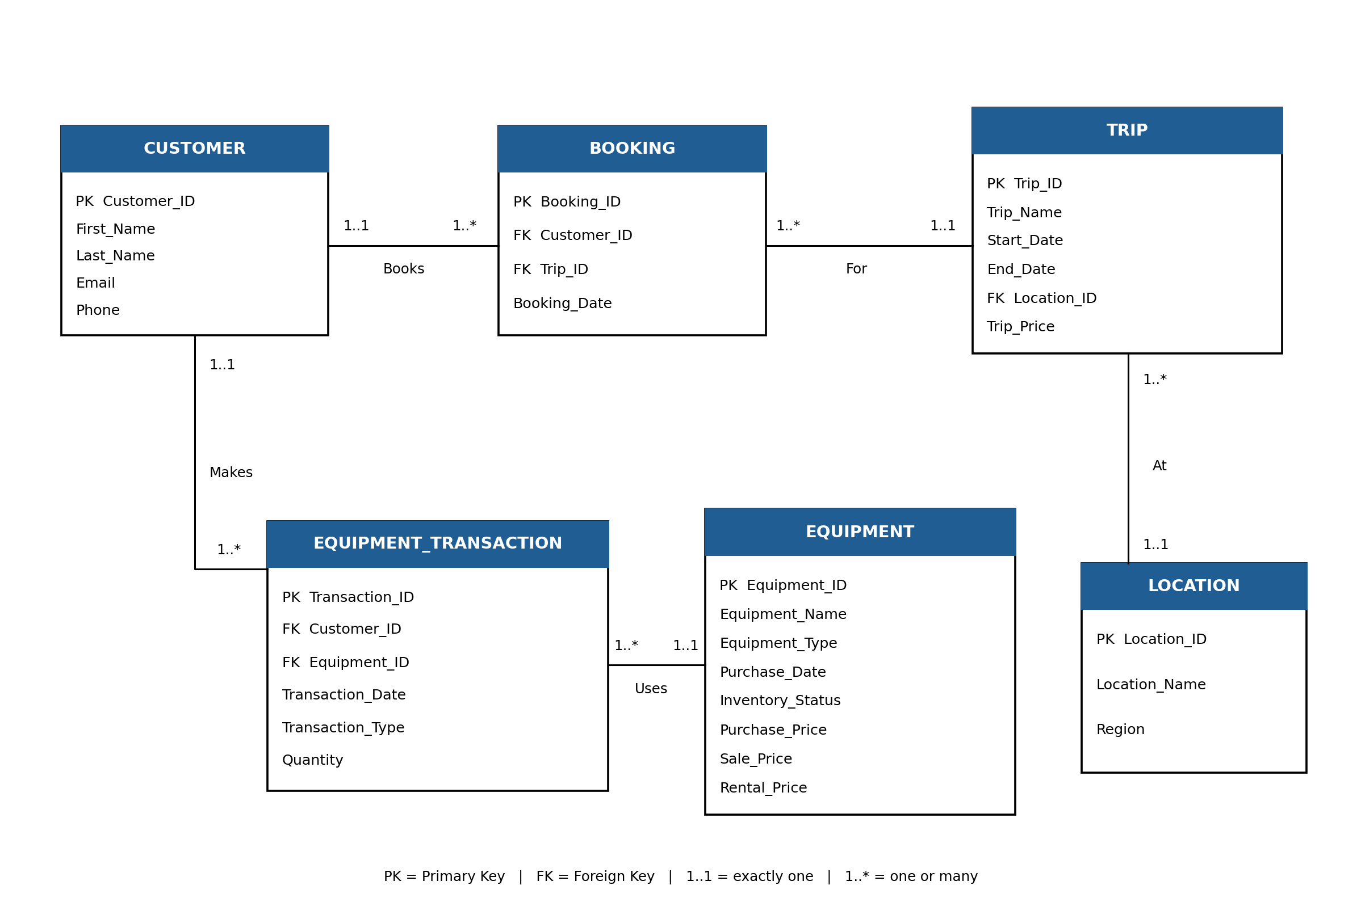

Screenshots of Python Script Output for all table data: (next pages)
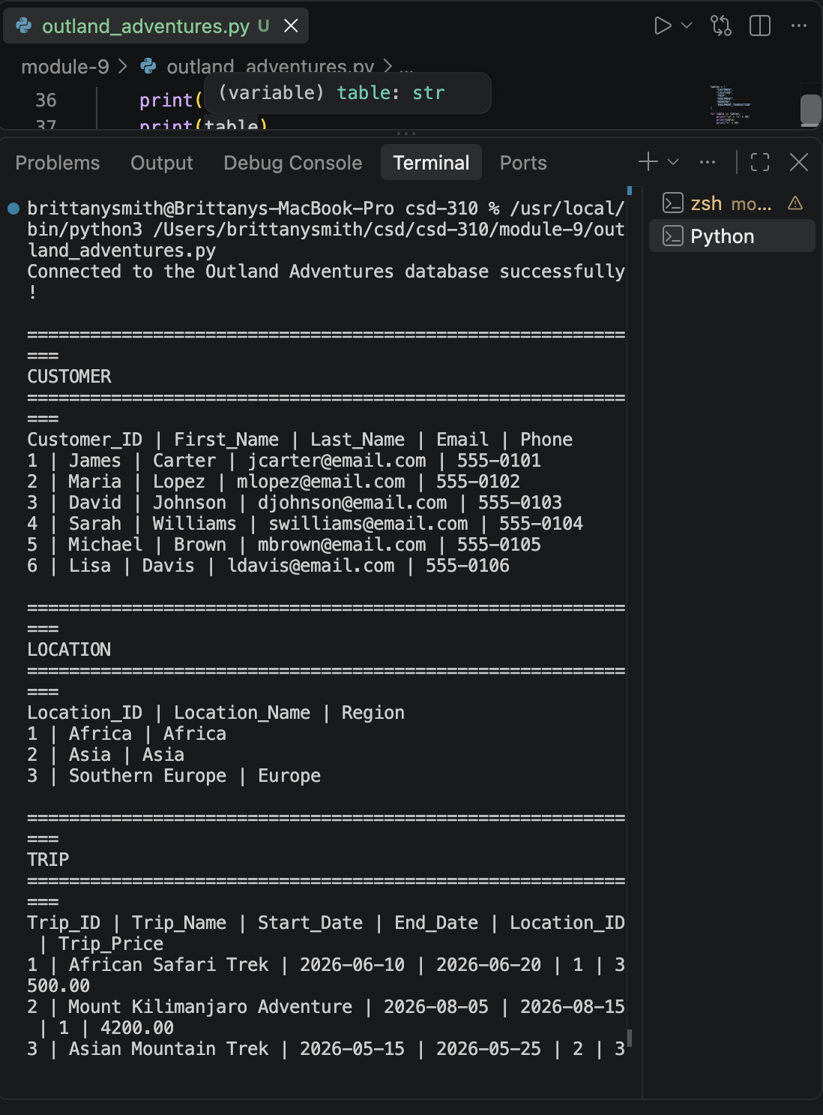
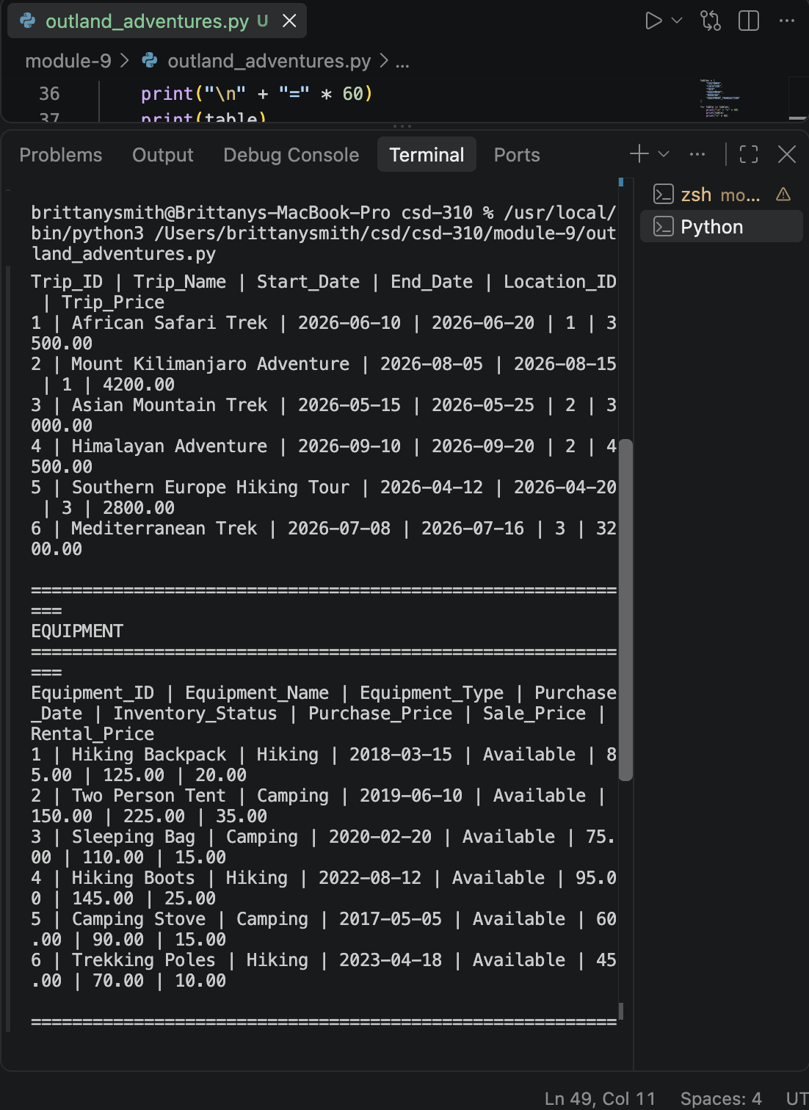
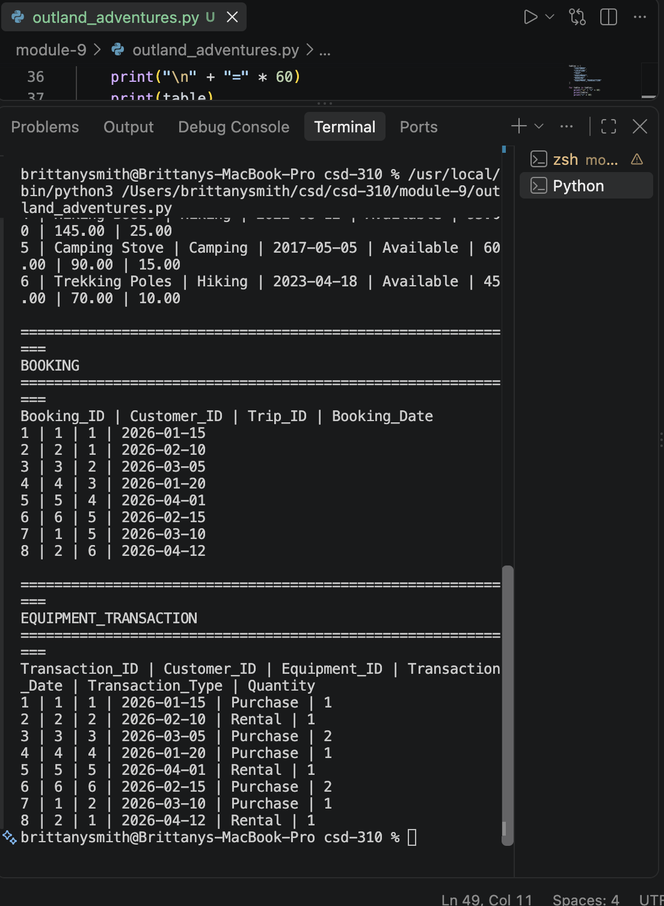
MySQL Tables:
